iPad Program Description
The iPad program at Bishop Guilfoyle Catholic High School provides tools and resources to the student. Effective teaching and learning with iPads integrates technology into the curriculum anytime, anyplace. As the senior class of 2013 we want to simulate college life, on the job and effective use of technology. The senior pilot project will also assist us in what works and what we can do better for future students at BG.
Students must abide by the policies of the school to effectively use the iPad to enhance learning in the classroom and outside the classroom.
The policies, procedures and information within this document apply to all iPads used at Bishop Guilfoyle Catholic High School. Teachers may set additional requirements for use in their respective classroom.
Above all, the iPad program at BG is an academic program and the policies governing the use of the iPad support its academic use.
A. iPad Distribution and Care
Students are issued iPads at the beginning of the school year. The iPads are the property of BG and students are expected to use the iPads in conformity with the school Acceptable Use Policy. Students are responsible for the general care of the iPad they have been issued by the school. iPads that are broken or fail to work properly must be taken to the IT Department (room 222) for an evaluation of the equipment. A PR ticket will need to be completed.
Students/parents are solely responsible for the care and safekeeping of student iPads. Any loss or damage to iPads (outside of reasonable wear and tear), regardless of the cause, will be the strict financial responsibility of the students/parents. Students must immediately report damage or loss, including theft, to BG IT Department. Students/parents are not permitted to repair, alter, modify or replace iPads without express authorization from BG IT Coordinator. Under no circumstance will BG replace or repair a student iPad without the required payment from the student/parent.
Bishop Guilfoyle did purchase apple-care for these devices but it does not cover accidental damages or stolen. As stated in the Student iPad Acceptable Use Agreement, families are responsible for any damage or loss of the iPad. We encourage families to check their homeowner’s insurance policy to see if the device is covered or to consider purchasing a separate policy for the device. There are several firms that provide insurance protection for your iPad. While we do not endorse any one firm, here are two that come with good recommendations. Worth Avenue Group will cover accidental damage and loss due to theft. Their web site is: http://www.worthavegroup.com/ipad. Square Trade will cover accidental damage only. Their web site is: http://www.squaretrade.com/ipad-landing.
Estimated Replacement Cost: Ipad – $575.00
Case/keyboard – $80.00
Cracked Screen - $200.00
B. General Precautions and Guidelines.
Students must have their iPads, iPad covers (on the device) with them at school every day.
Students are responsible for keeping their iPads’ batteries charged for school each day.
Students may not remove or circumvent the management system installed on each iPad. This includes removing restrictions or “jailbreaking” the device.
iPads should always be within protective cases that BG has supplied.
Only use a soft cloth to clean the screen, instructions given to student on how to clean.
Cords and cables must be inserted carefully into the iPad to prevent damage.
iPads must never be left in an unlocked locker, unlocked car, or any unsupervised area.
Students may not remove or alter tags on the iPad’s cover.
The “find my iPhone/iPad” function must be on at all times.
Printers are available on campus for limited student use as directed by the teacher of a class.
C. Sound, Music, Games, Pictures, or Programs
Sound must be muted at all times unless permission is obtained from the teacher for instructional purposes.
During the school day, 7:30 AM to 4:00 PM, earphones may only be used in the library, for instructional purposes or online learning. Permission may be given for use of earphones by a teacher in a classroom. During the school day students may not use earphones in other areas on campus.
Internet games and game apps are not allowed on the iPads.
The software/apps originally installed by BG must remain on the iPad in usable condition and be easily accessible at all times. From time to time the school may add software applications for use in a particular course.
Students are not allowed to load extra software/apps on their iPads, unless instructed by a teacher.
Students may store their own photographs and music on their iPads, related to clubs or curriculum projects.
The use of Google Drive will be used for storing your data files.
D. Prohibited Use
Illegal installation or transmission of copyrighted materials.
Any action that violates existing school rules or public law.
Sending, accessing, uploading, downloading, or distributing offensive, profane, threatening, pornographic, obscene, or
sexually explicit materials.
Use of chat rooms not authorized by the teacher for academic use.
Sites selling term papers, book reports, and other forms of student work.
Messaging services.
Spamming: sending mass or inappropriate emails.
Gaining access to other students’ accounts, files, and/or data.
Use of the school’s internet/E-mail accounts for financial or commercial gain or for any illegal activity.
By passing the BG web filter through a web proxy.
Photographing or video recording on campus without the permission of a teacher for academic purposes or in support of a school program.
Student sharing of their passwords, addresses, or other personal information on the Internet without the authorization of a parent or BG administrator.
Copying certain Internet materials or reproducing materials without the permission of the author or other right-holder.
Plagiarizing academic materials.
Using or possessing hacking software.
No alterations to iPad settings unless instructed by IT Coordinator
DO NOT update software unless instructed by IT Coordinator
E. General Rules for iPad Use
Students that fail to charge the battery on their iPad, forget to bring the iPad to school, or need assistance with iPad related software or hardware on the device must be to class on time. Students must have the permission of their teacher to address these issues during class time. Students late to class due to iPad or technology related issues without permission will follow the same discipline guidelines established in the student handbook.
Students may use the iPad only for academic purposes on campus between 7:30 AM and 4:00 PM.
Students may not use other student iPads nor have them in their possession.
In consideration for receiving the iPad from BG, each student and his or her parent or legal guardian agrees not to sue and hereby releases, waives, discharges, holds harmless, indemnifies, and defends Bishop Guilfoyle Catholic High School as well as their respective employees, personnel, staff, volunteers, agents, directors, affiliates, and representatives, from any and all liability, losses, damages, claims, actions, and causes of action of every nature for any and all known or unknown, foreseen or unforeseen, bodily or personal injuries, property damage, or other loss, whether claimed by the student, parent, legal representative, or any third party, relating in any way to the use of the iPad furnished by BG to the student.
This iPad Acceptable Use Policy applies to BG students at all times, whether or not the students are on campus, as BG students are school representatives at all times.
Individual school iPads and accessories must be returned to the BG IT Department at the request of the school when a student graduates or ceases to be a registered student at BG, or for disciplinary action.
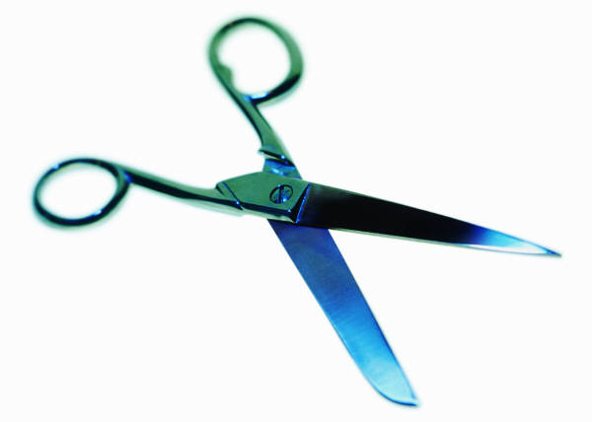
--CUT and Return by Tuesday, September 2, 2014
This document was distributed August 2014. By signing I understand the guidelines for the iPad Policy and Guidelines
Student Name: ______________________________ Student Signature: _________________________ Date: ___________
(print)
Parent/Guardian Signature: _______________________ Date: ___________

