1. Sign out of **eBackpack APP**.
2. Go into eBackpack **web version** and sign into ebackpack http://www.itbghs.net/Student.html

ID: Student ID number   
Password: you created

1. Click on arrow beside your name and click on “My Setting”
2. Select External Application on the right

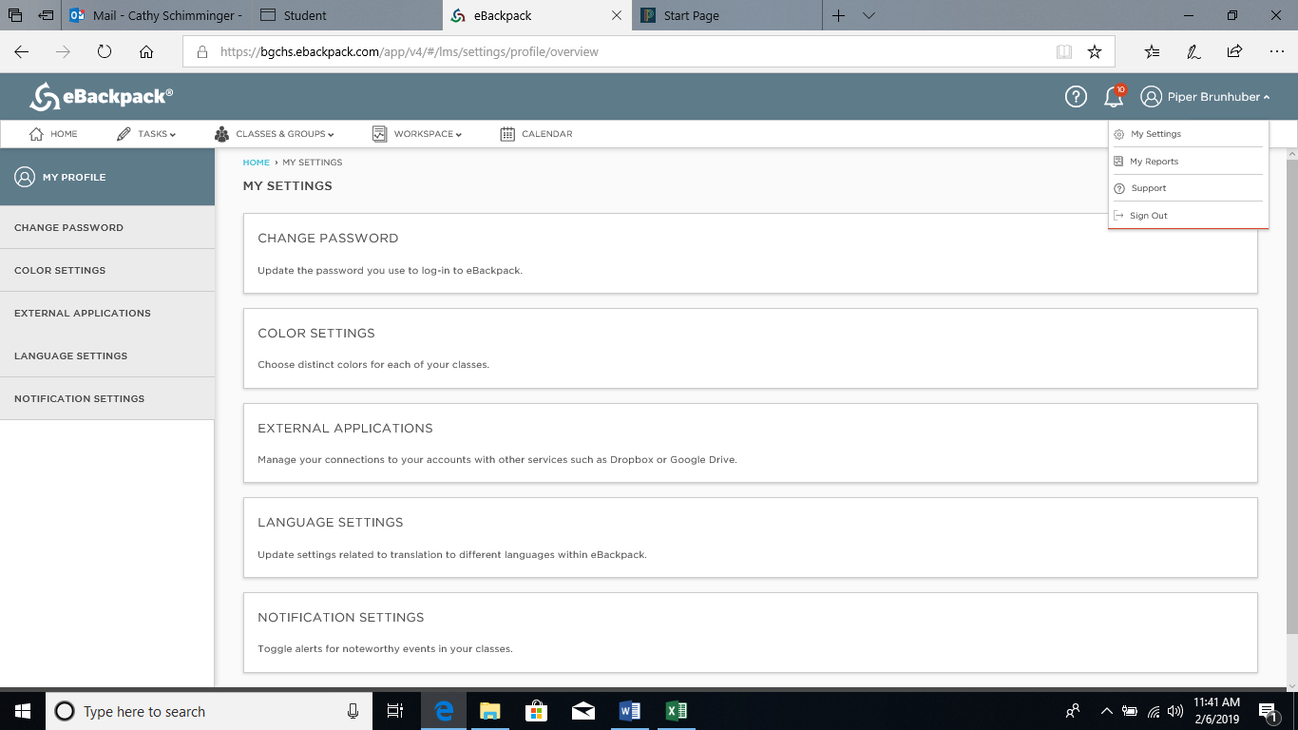

1. Select Google
2. Sign in using your google ID: (email) and password: (you created)
3. Click Allow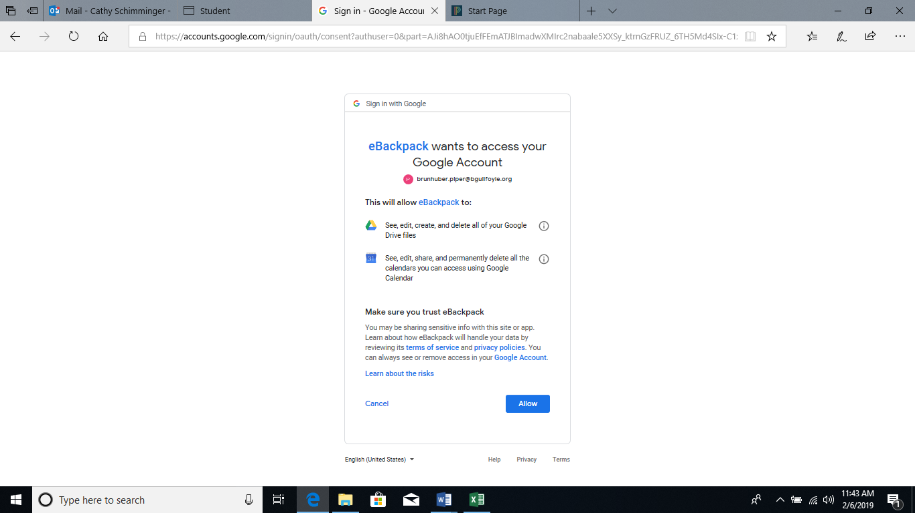
4. Sign out of eBackpack web version
5. Sign into App Version

Account: bgchs

ID: Student ID number (1…. )

Password: You created